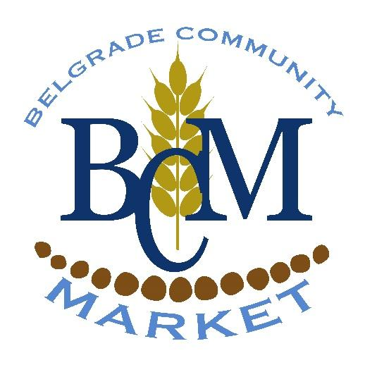
Belgrade Community Market - 2019
Handmade, Homemade, Homegrown in Our Hometown
Every Thursday Evening, July 11th – Sept 12th
Lewis & Clark Park – 205 E Main St, Belgrade, MT
Market Hours: 4pm-7pm
Set-up: 3pm - Take Down By 8pm
P.O. Box 983 Belgrade, MT
(406) 813-0258

*Market will be held rain/shine unless Severe Thunderstorms are in the forecast - in that case, Market will be called by 1pm the day of the market and vendors will be notified promptly.
Market Regulations & Vendor Contract:
FEE:
- One Time Booth Fee for a Full Season, Permanent Space is $150 (no additional vendor fee during the season). If a vendor commits to and attends all 10 market days, they will receive $50 back upon completion of the season. (NOTE: All Full Season Vendors will be allowed one night off if a market manager is given 48 hours notice of the vendor’s absence. If there are extenuating circumstances, please contact a Market Director.)
- The Per Night Booth Fee is $10 per evening for a 10’X10’ space. Kids booths are $5 a night.
- Non-profits & Brick & Mortar Stores, please contact a Market Director. *NO Direct Sales/MLM Business*
- All nightly fees are Non-Refundable and are due by 3:45pm the day of the market if not paid prior.
- If you are a no show on your scheduled night (without proper notice), there will be a Buy Back Fee In Addition to Regular Fees to be allowed space at the next market. 1st offense: $25, 2nd offense: $50, and 3rd offense: you will no longer be eligible to be a vendor. There is a waiting list of people who would like to be vendors. Without notice, we are not able to line up another vendor to fill empty spots. Please be courteous and give the market managers 48 hours notice if you cannot attend the market (barring extenuating circumstances).

ATTENDANCE:
- Please check in with a Market Manager by 3:45pm the day of the market. Any seasonal OR nightly vendor who does not check in by 3:45pm (without notifying the market staff beforehand) becomes a “no show” (see fee schedule and no show notes above).
- A vendor CANNOT give their booth away. Only the Market Directors have the right to reassign booths.

PARKING:
- Parking will be at a premium at Lewis and Clark Park. As a vendor, please unload and then move your vehicle to the side streets to allow for customers to park closer to the park. (If you need to have a spot with street access please let a manager know prior to the market. i.e. farm trucks with a large volume of product who “sell” from the truck.) We will do what we can to accommodate those who need one of these spots, but they will be very limited. If you know you need one of these spots, we HIGHLY suggest you pay our Full Season Booth Fee to guarantee your spot for the season.
- ABSOLUTELY NO PARKING/DRIVING ON THE GRASS. If you drive on the grass you will be responsible to pay for repairs to the sprinklers, park grounds, etc.

SET-UP:
- You are responsible for your own display (tables and chairs are NOT supplied). We do recommend vendors bring their own awning as many of our spots are in the sun either part or all evening.
- Vendors may start set-up at 3:00 pm on the day of the market and must check in with a Market Manager prior to set-up. Any space not occupied by 3:45pm will be offered to walk up vendors in the order they arrived.
- Absolutely NO TENT STAKES. The park does have underground sprinklers and if you hit one you will be responsible for the damage. Please plan on using sandbags/filled milk jugs, etc. to weigh down any canopies you wish to use.
- This is an open-air, outdoor venue so please plan for such. i.e. canopies, sunscreen, water, umbrella, etc. Market will be held rain/shine unless Severe Thunderstorms are in the forecast - in that case, Market will be called by 1pm and vendors will be notified promptly. Please check your email!
TAKE-DOWN:
- The Market ends at 7pm. Please do what you can to have everything packed up and out of the park by 8pm.
- Sellers MUST CLEAN THEIR OWN AREA at the conclusion of each market. There will be a charge of $25 if we have to clean up after you. Be considerate and pick up trash whenever you see it.
FOOD VENDORS:
- Health Department Regulations at this Market apply to ALL vendors. If you plan to sell homemade/handmade/pre-packaged food items, you are required to fill out a “Farmers’ Market Health Form” from the Gallatin County Health Department. After receiving confirmation from the Health Dept., please send it with your registration to the Belgrade Community Market. Always carry a copy of the form or food service license and make it available on-site at the Market. A Market Manager OR a Health Department Representative will ask to see this at every Market so please have it visibly displayed on the booth. PLEASE CONTACT the Health Dept. FOR THIS FORM! Gallatin City-County Health Department @ (406) 582-3120
- Food Vendors must supply an additional trash can for public use at their booth.

Standard Season Rules and Regulations
- Sales at the Community Market are limited to garden produce, locally handmade crafts, flowers, herbs, houseplants and homemade goods by vendors within 40 miles of Belgrade, Montana.
- NO Direct Sales/MLM Companies
- Sellers MUST provide their own tables, change, bags, garbage cans (if necessary), hand washing stations (if necessary), and advertising signs. Sellers determine their own prices.
- If you are selling food products, you must either attend a Health Department meeting in April/May or contact the Health Department at (406) 582-3120.
- NO smoking. NO Alcohol. NO Dogs or Large Pets of Any Kind at Vendor Booths.
- Vendors are not allowed to give away or sell animals.
- No sales of Alcohol or Tobacco Products.
- Sellers are required to be ready to sell when the market opens at 4pm and sell until 7pm when the market ends.
- All goods at the market must be made or grown by the vendor.
- The items must be grown or made by the seller to support economic well-being and the development of home based and local businesses.
- No food sales (unless licensed by the State of Montana, documentation required.)
- No medical, promise of a cure or advocating for anything medical (no care providers, massage therapists, acupuncturists, chiropractors or products taken orally or on the skin promising to relieve a medical condition.)
- No petitions.
- Any concerns that may arise during the market will be decided upon - as the final decision - by the onsite market managers.
Please retain a copy of this form for your records.
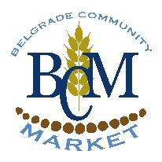
Belgrade Community Market
Vendor Registration Form – 2019

(PLEASE PRINT A HARD COPY TO FILL OUT AND SEND TO US - DO NOT FILL IN THE BLANKS ONLINE - THANKS!)

PRINT NAME: ______________________________________________________________________________
BUSINESS NAME (not required): _______________________________________________________________
ADDRESS:_________________________________________CITY:__________________________ZIP:________
PHONE: ______________________________________EMAIL:_______________________________________
CATEGORY & DESCRIPTION OF ITEM(S) INTENDED FOR SALE:_________________________________________
__________________________________________________________________________________________
(Example of categories: growers, artist, crafters, non-profits, kid booth, homemade food. Remember that YOU must make or grow all of the items sold at your booth.)
MAY WE GIVE YOUR NAME AND NUMBER OUT TO CUSTOMERS WHO REQUEST IT? ______Yes ______No
- FULL SEASON VENDORS: Please list top 3 booth # choices: first_________, second_________, third________
- All booths are filled into certain categories with a limited number of booths available for each category. The BCM Market Managers reserve the right to determine the appropriate vendor selection for a successful market.
- All Booths are 10’ x 10’ - a maximum of two vendors sharing a booth.

PLEASE SIGN & DATE BELOW:
I/we have read and agree to abide by the Belgrade Community Market Regulations and Contract.
I/we will make sure that anyone assisting me with my booth will also follow these Regulations and Contract.
I/we agree to treat fellow vendors, customers & Market volunteers with respect and courtesy.
I/we understand that the Market follows the guidelines of the City of Belgrade’s zero tolerance for Bullying.
I/we the applicant(s) have read the “Conditions of the Market” above and agree to abide by said conditions. In addition, I/we, the applicant(s), do expressly release the Producer (Belgrade Community Coalition and its staff and volunteers) and the City of Belgrade from any and all liability for any damage, injury or loss to any person, business or property, which may arise from the licensing and occupation of the exhibit space by the applicant(s).
I/we agree to hold and save the Producer and owners of the show sites harmless of any damage, injury or loss by reason thereof.
I/we understand that the fee is not refundable.
I/we give permission to use my name, business name, slid/image descriptions, item prices, photographs, videotape, or images of my items or me for any and all purposes.
I/we understand that this Contract is for the safety & success of the Market.
I/we realize that if I do not follow these rules, I am thus, choosing to forfeit my booth.

VENDOR SIGNATURE: ____________________________________________ DATE:_____________
PAYMENT:_________________ CASH/CHECK:________________ Full Season Vendor: Y/N_________
Nightly Vendors - Dates Interested:____________________________________________________
_________________________________________________________________________________
- FEE: Seasonal $150, Nightly $10 per night/ $5 for kids booth (kids 17 and under, parent must be present)
- All Nightly Fees must be made by 3:45pm on the day of the market. At that point, all remaining booths will be offered to those on the waitlist or to walk ups. Nightly Booths are assigned first come first serve basis, so the earlier we receive payment and registration, the more likely you will be to be to get a spot at the Belgrade Community. **We will begin taking reservations for NIGHTLY BOOTHS beginning June 1, 2018.
2019 Registration Form – (Turn in this page along with payment)
PLEASE WRITE ALL SPECIAL REQUESTS ON THE BACK OF THIS FORMS. NOT ALL REQUESTS CAN BE HONORED, BUT WE WILL TRY.

